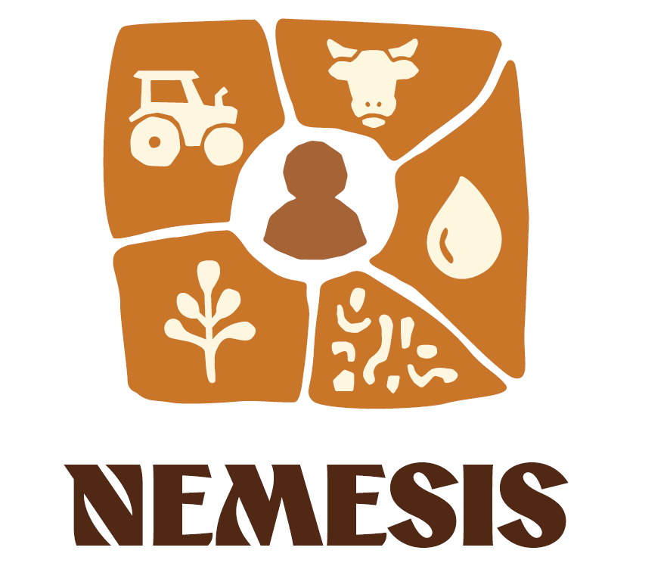

Open Call 1: Proposal template

Contents
Guidance for the preparation and structure of the proposal 3
Proposal template 4
Section 1: Description of the applicant 4
Section 2: Description of the applicant 5
Section 3: Alignment and Excellence 6
Section 4: Capacity and implementation 8
Section 5: Expected contribution / impact 10
Section 6: Ethics 11
Attachments 12

Disclaimer
Funded by the European Union (Nemesis; Grant agreement No. 101219087). Views and opinions expressed are however those of the author(s) only and do not necessarily reflect those of the European Union or the European Research Executive Agency (REA). Neither the European Union nor the granting authority can be held responsible for them.

Guidance for the preparation and structure of the proposal
The structure of this proposal template must be followed when preparing your application. It has been designed to ensure that the important aspects of your proposal are presented in a way that will enable the experts to make an effective assessment against the pre-defined evaluation criteria. Please note that only proposals that successfully address the aspects mentioned below are eligible for funding. Proposals using other templates cannot be considered for evaluation.
- Formatting conditions: font Calibri, pt 11, single lined spacing
- Language: English is the only acceptable language. Proposals submitted in any other language will not be evaluated.
- Applicants are required to respect the maximum text limits specified for each section of this template. These limits are intended to ensure fairness and comparability among all proposals. Text exceeding the indicated limits may not be evaluated.

Please note that proposals will be assessed based on their submitted content only, without consideration of potential improvements. Successful proposals must fully address all mandatory requirements to be eligible for funding. Significant content modifications will not be permitted during the grant preparation stage.

When considering the use of generative artificial intelligence (AI) tools for the preparation of the proposal, it is imperative to exercise caution and careful consideration. The AI-generated content should be thoroughly reviewed and validated by the applicants to ensure its appropriateness and accuracy, as well as its compliance with intellectual property regulations. Applicants are fully responsible for the content of the proposal (even those parts produced by the AI tool) and must be transparent in disclosing which AI tools were used and how they were utilized.
Specifically, applicants are required to:
- Verify the accuracy, validity, and appropriateness of the content and any citations generated by the AI tool and correct any errors or inconsistencies.
- Provide a list of sources used to generate content and citations, including those generated by the AI tool.
- Be conscious of the potential for plagiarism where the AI tool may have reproduced substantial text from other sources. Check the original sources to be sure you are not plagiarizing someone else’s work.
Acknowledge the limitations of the AI tool in the proposal preparation, including the potential for bias, errors, and gaps in knowledge.

The proposal will be kept confidential by the Nemesis consortium and by the proposal evaluators. Nonetheless, it is recommended not to disclose confidential or sensitive information. The Nemesis Coordinator will sign a sub-grant agreement, including confidentiality clauses, with the selected Open Call beneficiaries.

Publication date | 01 June 2026
Deadline for applications | 01 August 2026
Funding | Up to 100% funding of eligible lump-sum budgets
Total FSTP under OC1 | EUR 500,000 distributed across all third parties
Maximum amount per third party | Up to EUR 100,000
Targeted number of grants | 5-8
Selection | At least one third party per LL

For further information, please consult the Nemesis Open Call 1: Guidelines for applicants.

Section 1: Declarations
Please confirm the following statements and list the documents attached to the proposal.

Declaration checklist
The applicant is a single legal entity and is not a beneficiary, affiliated entity or associated partner of Nemesis.
The applicant has the operational capacity to implement the proposed activities.
The applicant has secure access to the proposed experimental site for the implementation period.
The applicant is not bankrupt and has not initiated bankruptcy procedures.
The proposal does not request double funding for the same activities.
The applicant accepts the conditions of the call and the use of English as the application language.
Any actual or potential conflict of interest has been disclosed.

Section 2: Description of the applicant
To be completed by the applicant
Proposal details
Title of proposal | [Insert the title of your proposal]
Selected Living Lab (LL) | [Choose one: Cyprus / France / Italy / North Africa (Tunisia/Algeria) / Spain]
General information
Name of organisation | [Insert legal name of the applicant entity]
Type of organisation | [Insert e.g. farmer, cooperative, SME, NGO, research institute, public authority]
Country | [Insert country]
If applicable: Website or social media channel of the organisation | [Insert website and/or social media links]
Responsible contact
First and last name | [Insert name of the main contact person]
Gender (optional) | [Insert gender: Female, Male, Non-binary]
If applicable: Affiliation | [Insert e.g. department etc.]
E-mail | [Insert email address]
Phone number | [Insert phone number]
Postal address | [Insert full postal address]
Role in the Organisation | [Insert role in the organisation]

Section 3: Alignment and excellence; Score: 0-5
Please provide concise but sufficiently detailed information. Where relevant, refer to the LL-specific requirements in the Guidelines for applicants.

Experimental site – basic information
Name of experimental site (if applicable) | [Insert site name]
Country / region / district / municipality | [Insert the full location of the site]
Coordinates | [Insert longitude and latitude of the site]
Site size (ha) | [Insert size in hectares]
Main land use / production system | [e.g. agroforestry, soil-water system, mixed farming, livestock, permanent crops]
Status of land access | [ownership / lease / formal access agreement / other formal arrangement]

Relevance of the applicant and the experimental site to the selected Living Lab (LL)
[Describe why the applicant and the proposed site are relevant to the selected LL. Explain how the site fits the LL-specific geographic scope, land-use context and operational logic. Max. 350 words.]

Soil challenge(s) addressed and thematic fit
[Describe the primary desertification / land degradation -related and/or soil-health challenge(s) addressed by the proposal and explain how they align with the thematic focus of the selected LL. Max. 350 words.]

Overall objective and expected contribution to Nemesis
[Summarise the overall objective of the site and explain how it will contribute to the implementation of Nemesis and to the strengthening of the selected Living Lab. Max. 350 words.]

Stakeholder engagement and co-creation approach; communication and dissemination activities
[Describe how you will engage local stakeholders and contribute to LL co-creation, including workshops, demonstrations, visits or other interactions, where relevant. Outline how you will contribute to the Nemesis outreach (communication and dissemination activities) Max. 350 words.]

Section 4: Capacity and implementation; Score: 0-10
Provide information demonstrating that the applicant can implement the proposed work plan within the required timeframe and cost-effective budget.

Team and expertise
Name / role | Area of expertise | Relevant experience for this proposal (Max. 80 words.)
[Insert name / role] | [Insert expertise] | [Summarise relevant experience]
[Insert name / role] | [Insert expertise] | [Summarise relevant experience]
[Insert name / role] | [Insert expertise] | [Summarise relevant experience]
[Insert name / role] | [Insert expertise] | [Summarise relevant experience]

Site maturity and operational readiness
[Describe the maturity of the site, including current operation, relevant experience, available baseline information, access for monitoring and demonstration, and readiness to implement proposed activities. Max. 350 words.]

Work plan overview
Activity / task | Description of planned work | Indicative timing | Expected evidence
Monitoring / baseline activities | [Describe the activity] | [e.g. M1-M12] | [Describe expected evidence]
Testing of management practice(s) / solution(s) | [Describe the activity] | [e.g. M1-M12] | [Describe expected evidence]
Stakeholder engagement / co-creation | [Describe the activity] | [e.g. M1-M12] | [Describe expected evidence]
Communication / demonstration / dissemination | [Describe the activity] | [e.g. M1-M12] | [Describe expected evidence]

The final milestone structure and payment-linked conditions will be defined in the sub-grant agreement. The table below follows the indicative logic described in the Guidelines for applicants.
Indicative milestone and deliverable plan
Phase | Indicative timing | Key milestone(s) | Main deliverable / evidence
MS1  Early implementation and baseline phase | M1–M12 | [Characterisation of site, baseline activities, first stakeholder engagement / demonstration activity] | [Inception and engagement report]
MS2  Co-solution  testing and assessment phase | M13–M24 | [Testing of selected management practice(s) / solutions; contribution to monitoring and assessment] | [Intermediate progress report]
MS3  Final implementation phase | M25–M36 | [Communication of results; final outputs and evidence delivered] | [Final implementation report]

Please provide a realistic and cost-effective lump sum budget, ensuring the best value for money for the activities proposed for implementation. Indirect or overhead costs are not eligible. Detailed information about the cost categories and the eligibility of costs is provided in the Guidelines for applicants.

Budget overview
Category | Amount (EUR) | Short justification
Personnel costs | [Insert amount] | [Brief justification]
Travel | [Insert amount] | [Brief justification]
Other goods, works and services | [Insert amount] | [Brief justification]
TOTAL COSTS | [Insert amount] | [Brief justification]

Section 5: Expected contribution / impact; Score: 0-5
Explain the expected contribution of the experimental site to the selected Living Lab, to the Nemesis Mission and to the wider uptake of soil-health-related practices and knowledge.

Added value for the selected Living Lab
[Explain how the proposed site will strengthen the selected Living Lab, including representativeness, demonstration potential, knowledge generation or stakeholder reach. Max. 350 words.]

Expected results and contribution to capacity building, practice uptake and policy relevance
[Describe the expected practical results of the proposal and their possible contribution to capacity building, demonstration, practice uptake, replication and/or policy relevance. Max. 350 words.]

Sustainability and longer-term perspective
[Describe how the site, activities or results could remain relevant beyond the funded implementation period. Max. 250 words.]

Section 6: Ethics
Please complete this section by indicating “Yes” or “No” for each field. For any affirmative answers, briefly explain how the issue is addressed. Ethicsissues will not directly affect the scoring, but proposals must demonstrate compliance with EU and national regulations to be eligible for funding.
Ethics issue | Yes / No
Does this activity involve interventions (physical, including imaging technology, behavioural treatments, etc.) on the participants? | [YES / NO]
Does this activity involve processing personal data? | [YES / NO]
Does this activity involve further processing of previously collected personal data (including pre-existing data sets or sources)? | [YES / NO]
Is it planned to export personal data from the EU to non-EU countries? | [YES / NO]
Is it planned to import personal data from non-EU countries into the EU or from a non-EU country to another non-EU country? | [YES / NO]
Does this activity involve the processing of personal data related to criminal convictions or offences? | [YES / NO]
Will some of the activities be carried out in non-EU countries? | [YES / NO]
If non-EU countries are involved, do the activities undertaken in these countries raise potential ethics issues? | [YES / NO]
Is it planned to use local resources (e.g. animal and/or human tissue samples, genetic material, live animals, human remains, materials of historical value, endangered fauna or flora samples, etc.)? | [YES / NO]
Is it planned to import any material (other than data) from non-EU countries into the EU or from a non-EU country to another non-EU country? | [YES / NO]
Is it planned to export any material (other than data) from the EU to non-EU countries? | [YES / NO]
Could the situation in the country put individuals taking part in the activity at risk? | [YES / NO]
Does this activity involve substances or processes that may cause harm to the environment, animals or plants? | [YES / NO]
Does this activity deal with endangered fauna and/or flora / protected areas? | [YES / NO]
Does this activity involve substances or processes that may cause harm to humans, including those performing the activity? | [YES / NO]
Does this activity involve the development, deployment and/or use of Artificial Intelligence? | [YES / NO]
Are there any other ethics issues that should be taken into consideration? | [YES / NO]

Attachments

Checklist
Attachment | Included (Yes/No) / comments
Proof of legal entity status | [Insert yes/no and comments]
Proof of access to the experimental site | [Insert yes/no and comments]
If applicable: Statement on the use of generative artificial intelligence | [Insert yes/no and comments]
If applicable: Any additional documentation on site maturity / operational capacity or relevance to the LL e.g. installed equipment, existing soil health data and monitoring programmes, ongoing or past projects, existing stakeholders engaged, previous site management, etc. | [Insert yes/no and comments]

